Honduras Mission 2016 – September 17-24
Next meeting March 9 @ 7:00pm in AMR

Missionary Soul
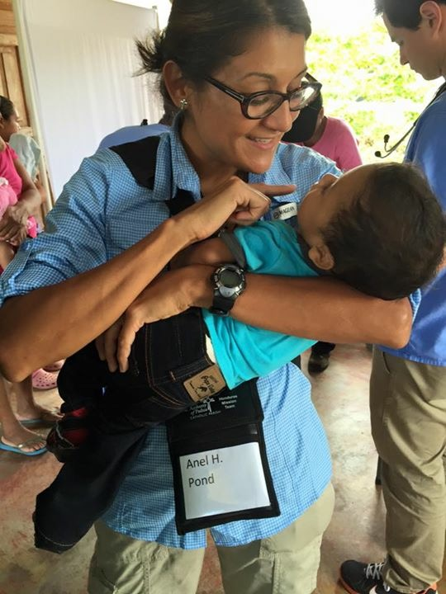
I never imagined that God would call me to serve as a missionary. Everything changed in February 2015. I started to feel a tug on my heart, something I never felt before. I felt it even stronger when I’d hear announcements about the Honduras mission trip. I didn’t understand this until I started to pray about it. As this calling grew within me, I asked my husband, sister and best friend to pray about it, too. Months went by and I questioned the value that I could provide to a mission trip focused on providing medical services. I have no medical background. Yet, I continued to pray, “Lord what do you want from me? What would I do there? I am willing to do Your Will, I will go to Honduras but you know my struggles”. I struggle with anxiety and insecurities linked to the fact that I never earned a college degree. The thought of going to an information sessions absolutely terrified me and would send me into a state of panic. But I did know one person, Dr. Teresa Romero, who went on the mission the prior year and involved with planning the next trip. We weren’t what you would call friends (she was my neighbor and pediatrician) but I knew her. So I pray, “Lord, I am willing…send me…but this is what I need from you…please put Dr. Romero in my path”. Months went by, I was taking a walk and suddenly I came upon Dr. Romero as she rode her bicycle on my path! I nearly pushed her off of her bike from the excitement I was feeling. I started crying, I was filled with joy. God had answered my prayers. I couldn’t believe it! That day was the last day to register for the Honduras mission trip. Looking back, I recall a moment before the encounter with Dr. Romero when I was urged to mail my passport application. I didn’t need it but felt like it was important to do. The Word says in Jeremiah 29:11-13 “For I know the plans I have for you”. A few days passed and I heard God speak to my heart, “You will translate”. God is faithful. God remained with me, showing me that we were all the same – no one greater, no one less – college degree or not. Friendships flourished that I never thought were possible. I teamed up with Dr. Chrissy Piefer to translate as each patient visited with her. I was with her day and night throughout the mission and we have a wonderful friendship today. God knew what He was doing all along. The list of great memories and moments of spiritual growth is long and I’m truly grateful. Reaching out to those in need and getting to know the hearts of those I journeyed with was an amazing experience. But the most moving and impactful part of my experience was not what I did for those beautiful and humble people in Honduras but what they taught me about myself. They are why I say I have a missionary soul. God continues to call me to serve. Do you feel the call? Anel Pond

